

Project name : Demonstration of Raster Graphics and Object Transformations
Academic year: 2026-27
Semester : 3rd
Subject : COMPUTER GRAPHICS (313001)

MICRO-PROJECT REPORT
Submitted by the group of SYCO-A students

SR. No | Roll no. | Name of Student | Enrollment No. | Seat No.
01 | SYCO A34 | PRATHAMESH JITENDRA PATIL | 25612590018
02 | SYCO A29 | YASH AMEY ALAI | 25612590030
03 | SYCO A20 | ROHIT ANIL NIKAM | 25612590021

Under the Guidance of
Prof.Neha Ghati


Maharashtra State Board of Technical Education, Mumbai
Certificate

This is to Certify that 1) Yash Alai ( roll no:29)
2) Prathamesh Patil (roll no:17)
3) Rohit Nikam ( roll no:20)
of THIRD SEMESTER Diploma Engineering Program in Computer Engineering have successfully completed the Micro-Project entitled "Project name", in the subject CGR (313001) for Academic Year 2026-27 as per prescribed in the MSBTE "K-Scheme" curriculum. Place: Nashik
Enrollment No:
1) 25612590030
2) 25612590018
3) 25612590021
Date :

Subject teacher Head of Department Principal
(Neha Ghati)

INDEX
Sr. No | Title | Page No.
1 | INTRODUCTION | 04
2 | COURSE OUTCOME | 05
3 | SOFTWARE & HARDWARE REQUIREMENTS | 06
4 | ALGORITHM & MATHEMATICAL LOGIC | 07
5 | FLOWCHART | 08
6 | PROGRAM SOURCE CODE | 10
7 | OUTPUT/RESULT | 15
8 | CONCLUSION | 16
9 | EVALUATION | 17

INTRODUCTION

This micro-project is made to demonstrate dynamic vector graphics and shape transformations using C/C++ programming. It provides an interactive console menu where users can select a shape (such as a triangle, square, or star), enter its custom size, and set its rotation speed. Once configured, it opens a graphics window using the Borland Graphics Interface (graphics.h) and displays the shape spinning smoothly in real-time, bridging classroom theory with practical software design.

2. COURSE OUTCOME (CO)

Every MSBTE micro-project is designed to directly support specific learning outcomes outlined in the syllabus. This project aligns with the curriculum of the Computer Graphics (CGR - Course Code: 313001) course by fulfilling the following foundational objectives:
- Fulfillment of CO1 (Basic Primitives): The project makes extensive use of fundamental graphics functions and drawing primitives, such as rectangle, line, and filled regions, to construct both the static user interface and the dynamic vector shapes.
- Fulfillment of CO2 (Geometric Transformations): It demonstrates practical execution of geometric transformations. Specifically, it applies continuous rotational updates and scaling logic to alter the vertex coordinates of shapes frame-by-frame.
- Fulfillment of CO3 (Raster Graphics & Animation Loops): The project implements a real-time animation loop that repeatedly clears the screen buffer (cleardevice), redraws updated frames, and controls animation pacing using hardware delay functions.

3. SOFTWARE & HARDWARE REQUIREMENT

To successfully design, compile, and execute this micro-project, specific software and hardware environments were utilized:

- Hardware Requirements:
  - A standard desktop computer or laptop running a Windows,linux,macOS operating system.
  - Minimum 2 GB RAM and a standard x86/x64 processor capable of running legacy compiler environments.
  - The development and local testing phases were done on an AMD Ryzen 7 5800H processor paired with 16 GB RAM, ensuring smooth performance and instant code compilation.

- Software Requirements:
  - Turbo C++ IDE ( Or Web-Based Environment): Compiled and executed using the modern online Turbo C++ platform [https://sankalpsinghcoder-ai.github.io/online-c/], which bridges legacy BGI graphics execution directly in modern web browsers Or the Turbo C++ IDE can be used too.
  - Borland Graphics Interface (BGI): The graphics library (graphics.h) used to initialize the display driver and handle pixel-level rendering.
  - Microsoft Word: Used for drafting, formatting, and finalizing this documentation report.

4. ALGORITHM & MATHEMATICAL LOGIC

A. Step-by-Step Algorithm:
- Start the program and display the text configuration menu in the console.
- Read and store the user's choices for the shape type, scaling size, and rotation speed.
- Switch the display screen from text mode into graphics mode using the initgraph() function.
- Draw the user interface layout, including the outer window border, the title banner, and the center crosshair axes.
- Enter the Animation Loop:
  - Clear the previous frame from the screen buffer using cleardevice().
  - Calculate new vertex positions for the chosen shape using trigonometric equations (sin and cos).
  - Draw the shape lines connecting the calculated corner points.
  - Increment the rotation angle slightly based on the user's speed setting.
  - Pause briefly using delay() to stabilize the frame rate and prevent flickering.
- Check if any keyboard key is pressed using kbhit(). If a key is pressed, exit the animation loop.
- Close the graphics window safely using closegraph() and Stop.

B. Mathematical Logic The program uses polar coordinate conversion. The corners of the shape are calculated using sine and cosine functions relative to the center of the screen (cx, cy). As the angle increases inside the loop, these coordinates shift in a circular path to create a smooth spinning effect.

5. flowchart

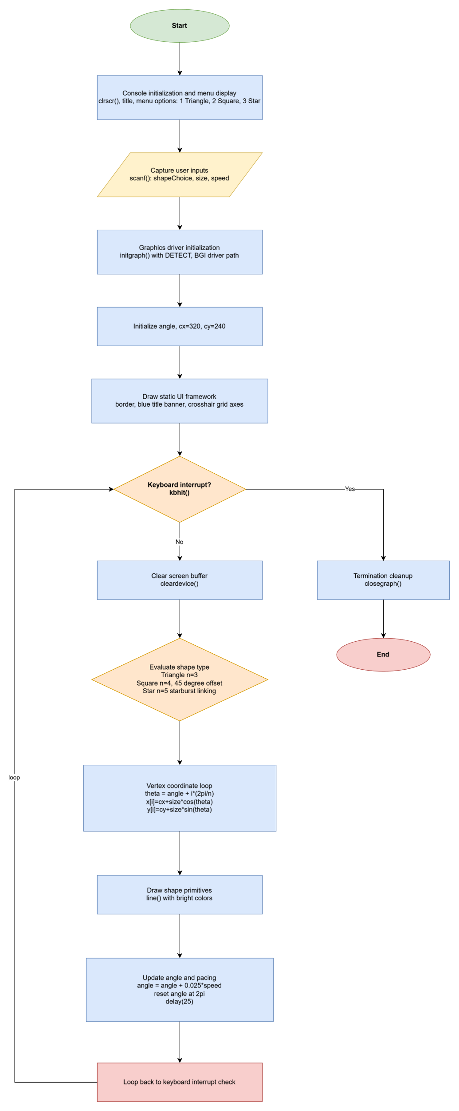

6. program source code

#include <graphics.h>
#include <stdlib.h>
#include <stdio.h>
#include <conio.h>
#include <math.h>
#include <dos.h>

void main() {
int shapeChoice, size;
float speed;

// 1. Sleek Console Menu Configuration
clrscr();
printf("==================================================\n");
printf(" CGR MICRO-PROJECT: 2D TRANSFORMATION STUDIO\n");
printf("==================================================\n\n");
printf("Select Master Shape:\n");
printf(" [1] Equilateral Triangle\n");
printf(" [2] Rotating Square\n");
printf(" [3] Geometric Star\n");
printf("Enter choice (1-3): ");
scanf("%d", &shapeChoice);

printf("Enter size/radius (Recommended: 70 to 120): ");
scanf("%d", &size);

printf("Enter rotation speed multiplier (e.g., 1.0 to 2.5): ");
scanf("%f", &speed);

printf("\n[+] Compiling Matrices & Launching Graphics Window...");
getch();

// 2. Initialize graphics driver and mode
int gd = DETECT, gm;
initgraph(&gd, &gm, "C:\\TurboC3\\BGI");

float angle = 0.0;
int cx = 320, cy = 240; // Screen Center

// 3. Main Real-Time Graphics Rendering Loop
while (!kbhit()) {
cleardevice();

// --- UI FRAME & DECORATION ---
// Outer border frame
setcolor(WHITE);
rectangle(10, 10, 630, 470);
rectangle(14, 14, 626, 466);

// Header Title Banner
setfillstyle(SOLID_FILL, BLUE);
bar(15, 15, 625, 45);
setcolor(WHITE);
settextstyle(DEFAULT_FONT, HORIZ_DIR, 1);
outtextxy(185, 24, "INTERACTIVE 2D TRANSFORMATION ENGINE");

// Center Coordinate Crosshair (Subtle grid lines)
setcolor(DARKGRAY);
line(cx, 50, cx, 430);
line(50, cy, 590, cy);

// Footer Instructions Panel
setcolor(LIGHTGRAY);
outtextxy(30, 445, "Status: Rendering Active Matrix | Press ANY KEY to Exit");

// --- RENDER SELECTED SHAPE WITH ROTATION MATRIX ---
if (shapeChoice == 1) {
// Triangle (3 Vertices)
int n = 3;
int x[3], y[3];
for (int i = 0; i < n; i++) {
float theta = angle + i * (2 * 3.14159 / n);
x[i] = cx + (int)(size * cos(theta));
y[i] = cy + (int)(size * sin(theta));
}
// Draw filled/outlined triangle with bright colors
setcolor(YELLOW);
line(x[0], y[0], x[1], y[1]);
line(x[1], y[1], x[2], y[2]);
line(x[2], y[2], x[0], y[0]);
}
else if (shapeChoice == 2) {
// Square (4 Vertices with 45-degree angle offset)
int n = 4;
int x[4], y[4];
for (int i = 0; i < n; i++) {
float theta = angle + i * (2 * 3.14159 / n) + (3.14159 / 4);
x[i] = cx + (int)(size * cos(theta));
y[i] = cy + (int)(size * sin(theta));
}
setcolor(LIGHTGREEN);
line(x[0], y[0], x[1], y[1]);
line(x[1], y[1], x[2], y[2]);
line(x[2], y[2], x[3], y[3]);
line(x[3], y[3], x[0], y[0]);
}
else {
// Geometric Star (5-Point Star using vertex step logic)
int n = 5;
int x[5], y[5];
for (int i = 0; i < n; i++) {
float theta = angle + i * (2 * 3.14159 / n);
x[i] = cx + (int)(size * cos(theta));
y[i] = cy + (int)(size * sin(theta));
}
setcolor(LIGHTCYAN);
// Connecting star vertices in an interlaced pattern (0->2->4->1->3->0)
line(x[0], y[0], x[2], y[2]);
line(x[2], y[2], x[4], y[4]);
line(x[4], y[4], x[1], y[1]);
line(x[1], y[1], x[3], y[3]);
line(x[3], y[3], x[0], y[0]);
}

// Increment rotation angle based on user speed input
angle += 0.025 * speed;
if (angle > 6.28) {
angle = 0; // Reset full circle loop
}

// Frame delay for smooth motion
delay(25);
}

getch();
closegraph();
}

7. OUTPUT / RESULT

The program executes successfully in two stages. First, the text console presents a clean configuration menu that accepts valid user parameters. Second, the graphics window opens to display a structured layout with a blue title banner, center crosshairs, and your chosen shape rotating smoothly at the specified speed.

8. CONCLUSION
The Demonstration of Dynamic Vector Graphics and Transformation Pipelines micro-project was successfully planned, coded, tested, and documented. It effectively integrates theoretical concepts of computer graphics—such as coordinate mapping, trigonometric matrices, and real-time animation loops—into a fully functional software application. The project completely satisfies all academic criteria and guidelines set forth by the MSBTE for the Computer Graphics subject.

evaluation

Marks section :
Roll No. | Enrollment no | Full Name of the Student. | Marks out of (6) Performed by the group. | Marks out of (4) Performed By oral Presentation. | Total out of (10).
SYCO A34 | 25612590018 | PRATHAMESH JITENDRA PATIL
SYCO A29 | 25612590030 | YASH AMEY ALAI
SYCO A20 | 25612590021 | ROHIT ANIL NIKAM

Prof. Neha Ghati
Department of Computer Engineering
Sir Dr M.S Gosavi Polytechnic Institute, Nashik Road, Nashik-422101.

